SE450 Final Project

Chris Rebolledo

DePaul University

November 24, 2016

**Class Diagram for Model**

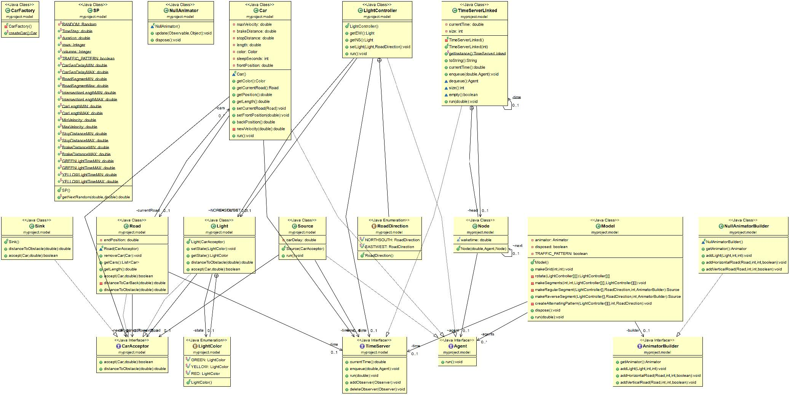

**Sequence Diagram for how a car updates its position**



**Time Summary**

|  |  |  |  |  |  |
| --- | --- | --- | --- | --- | --- |
| Week | 1 | 2 | 3 | 4 | **Total** |
| Design | 6 | 4 | 6 | 2.5 | **18.5** |
| Code | 5 | 4 | 6 | 10 | **25** |
| Big Bug | 0 | 3 | 4 | 6 | **13** |
|  |  |  |  |  | 56.5 |

**Notes on Patterns**

The First pattern that I implemented was a singleton pattern on the TimeServerLinked class. The problem that occurred was that I was not sure when I enqueuer to the TimeServer if it was referencing the same time server. This also allowed public access to the same TimeServer and allowed for Objects such as Car and Light to be “woke up” by the TimeServer. This make things a lot easier as there now was one thing keeping track of all the moving parts.

When Creating the sources of the roads, I needed a way to create car object easily. So one of the patterns we talked about extensively was a factory pattern. I used a static factory pattern as I was just creating the same car object over and over again. This pattern also allowed if need be to change the parameters in the future.

To control the lights, I used a state pattern to control them. The class light controller is actually altering the state of each light in an intersection. This solved 2 problems. One was how to control 2 lights at the same time, such as make north south green, and east west red, as well as providing one central place to control both lights.

**Successes and Failures.**

While I did learn many things over the course of this project, just personally I think I had many more failures. My successes consisted of finding places of where to use design patterns, and truly understanding the benefits of applying them to situations. But I think that’s where my successes ended. I think I failed a lot because I lacked a lot of knowledge of how OOP really works. While this exercise improved my coding skills a lot, it also showed my lack of OOP.

One of the biggest problems that I faced was understanding how things worked with the starter code. I feel that there were holes in terms of how things worked that I didn’t get resolved until very late. I am not sure if there was just holes in my core understanding or if it was just something I did not realize, but understanding how to put things together in this project was very difficult. At the same time, this allowed me to think of things differently.

Also I acknowledge my weakness in java swing. If I had more knowledge in utilizing the swing class, I think I would have had an easier time debugging problems as well as noticing errors. Example, toward the end of the project I had a hard time understanding why my formulas did not scale correctly. I thought I was with the equations, and struggled with it for a long time, until the last day where I realized it was because the values that I was getting in the constructors were not being utilized in the animations.

Time, something we all wished we all had more of. I believe if I had a bit more time to get everything working, or if I had a bit more information earlier on I could have completed this assignment as anticipated. I really wished there was not as much time spent on making sure all the objects were working correctly, and spend more time working on the design patterns.

Despite all the problems with this project, I am grateful, and humbled at the same time. It made me think that I have a long way to go as a programmer, but because of that I have a lot more to learn. I feel that it is true that until we face a hard obstacle, or fail we cannot grow, and from this project I definitely grew.